SECOND NOTICE

@Date

@WithPrefixName
@WithoutCityAddress
@City

Dear @WithPrefixLastName:

We did not receive any payment since our 1st notice dated @FirstNoticeDate. Your loan account has not been updated since @LastPayment. Your outstanding loan balance is P@Amount, excluding past due interest, penalties and other charges.

We are sure that you realize the consequences, not to mention the time and expenses, you will incur should we pursue legal action against you. We respectfully request you to visit us personally within five (5) working days from receipt of this letter.

Please disregard this letter if you have already settled your account.

Very truly yours,

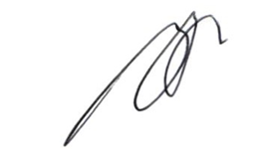

ROGER O. ESCARO
Corporate Microfinance Head

